GAIT ANALYSIS USING MACHINE LEARNING CLASSIFIERS
student: JUMMA MOHAMMAD TELI (231034661)
Supervisor: TAYYAB AHMAD ANSARI
MSc INTERNET OF THINGS AND FUTURE NETWORKS

Abstract: - This study explores the application of machine learning classifiers in the analysis of gait patterns using marker-based motion capture data. The research focuses on classifying walking speeds, which are crucial indicators of an individual's health, across various categories. A comprehensive dataset, containing kinematic and kinetic data from gait trials, was pre-processed and analysed using multiple machine learning models, including Random Forest, k-Nearest Neighbours (k-NN), Support Vector Machines (SVM), Neural Networks, Gradient Boosting, Decision Trees, Logistic Regression, and Naive Bayes classifiers. Among these, the Random Forest classifier emerged as the most effective, achieving an accuracy of 0.99, closely followed by the k-NN classifier with an accuracy of 0.98. The study highlights the importance of feature engineering, particularly in deriving key features like distance and velocity from raw marker data. Additionally, the research justifies the use of a chunking method for SVM training, enabling efficient processing of large-scale datasets. This approach ensured that the SVM could handle extensive data while maintaining high accuracy. The findings demonstrate the potential of ensemble methods and non-parametric models in gait speed classification, providing reliable tools for clinical and rehabilitation applications. The study's results contribute to advancing gait analysis techniques, offering practical insights for the early diagnosis of gait abnormalities and the monitoring of rehabilitation progress.

Keywords: Gait Analysis, Machine Learning, Walking Speed Classification, Motion Capture, Random Forest, k-Nearest Neighbours, Feature Engineering, Rehabilitation, Clinical Gait Analysis.
I. Introduction

Recent advancements in motion capture and machine learning technologies have significantly enhanced gait analysis, especially in the context of ankle rehabilitation (Muro-de-la-Herran,2014, Santos, G.,2022). Traditionally, gait analysis relies on marker-based systems to capture and assess movement mechanics. While effective, these systems are often time-consuming and prone to errors owing to the complexities involved in manual data handling (Chau, T. ,2001). The integration of machine learning (ML) into gait analysis addresses these challenges by automating the process, thereby improving both the accuracy and efficiency of the analysis (Baker, R. (2006). This is particularly beneficial for rehabilitation scenarios in which precise assessment of ankle movements is critical (Muro-de-la-Herran,2014). ML enables real-time diagnosis and monitoring, offering the capability to detect abnormalities in walking patterns early (Munoz-Ospina, 2022). This can be pivotal in the diagnosis and management of diseases such as Parkinson's disease and cerebral palsy, where early intervention can significantly impact patient outcomes (Munoz-Ospina, 2022).
This project focuses on analyzing gait phases using a dataset collected via an infrared cinematography system and an instrumented split-belt treadmill, capturing 3D marker positions and ground reaction forces (Santos, G.,2022). The goal is to determine the percentage duration of various gait sub-phases—stance, loading response, mid-stance, terminal stance, pre-swing, and swing—as influenced by walking speed (Whittle, M. W. ,2014). The aim is to develop a machine learning model to classify and analyze these gait phases, enhancing the efficacy of ankle rehabilitation (Baker, R. (2006).
II. Background and Motivation

Background: Gait analysis, the study of human walking patterns, is a critical tool in both clinical and research settings for diagnosing movement disorders, monitoring rehabilitation progress, and evaluating therapeutic interventions (Whittle, M. W., 2014). Traditionally, this analysis has relied on marker-based motion capture systems, which track movement using markers placed on the body. These systems generate extensive kinematic and kinetic data that provide detailed insights into gait mechanics, including joint angles, forces, and velocities (Hebenstreit et al., 2014). However, the high volume and complexity of this data present significant challenges, as it is often high-dimensional, noisy, and contains missing values (Chau, 2001). Additionally, manual data handling is time-consuming and prone to errors, complicating the accurate analysis of gait patterns.

Current methods for gait analysis are generally basic and best suited for low-dimensional signals, underscoring the need for more sophisticated techniques (Muro-de-la-Herran et al., 2014). The emergence of machine learning (ML) offers a transformative approach to overcome these challenges. ML provides a robust toolkit for automated feature extraction, dimensionality reduction, and pattern recognition, enabling more efficient and accurate analysis of complex gait data (Baker, 2006; Witten et al., 2011).

Motivation: This research is motivated by the critical need to enhance the accuracy, efficiency, and applicability of gait analysis in clinical and rehabilitation settings. Walking speed, a key indicator of an individual’s health and mobility, is particularly challenging to classify due to subtle variations and the high-dimensional nature of the data (Munoz-Ospina et al., 2022). Accurately assessing these variations is crucial for early diagnosis and effective treatment planning in conditions such as Parkinson’s disease, cerebral palsy, and other movement disorders (Muro-de-la-Herran et al., 2014).

The Gait Phase Database used in this study, which captures data from 21 healthy subjects walking at various speeds on a split-belt treadmill, provides a unique opportunity to explore the biomechanics of gait and test machine learning algorithms for classifying different gait phases (Hebenstreit et al., 2014). By leveraging machine learning techniques, this study aims to develop models that can classify walking speeds with high accuracy, even in the presence of noisy or incomplete data. The systematic evaluation of various classifiers—including Random Forest, k-Nearest Neighbors, Support Vector Machines, and Neural Networks—seeks to identify the most effective approaches for gait speed classification and to demonstrate their practical utility in real-world clinical applications (Breiman, 2001; Mannini & Sabatini, 2010).

Ultimately, this research aims to advance the field of gait analysis by providing clinicians and researchers with reliable, automated tools that can improve patient outcomes through more precise and efficient analysis of gait patterns. The findings have the potential to significantly contribute to the development of next-generation gait analysis systems, which are integral to modern healthcare and rehabilitation practices.

Significance of the study : This study contributes to the growing body of literature on using machine learning for gait analysis and ankle rehabilitation, offering valuable insights for fields like biomechanics, motor control, sports science, and rehabilitation (Privietha & Raj, n.d.; Alfayeed & Saini, 2021). The research effectively addresses the challenge of classifying walking speeds using high-dimensional marker data, with the developed techniques being applicable to other areas of human movement analysis, such as upper limb or balance studies (Mannini & Sabatini, 2010). By comparing multiple classifiers, this study clarifies the strengths and weaknesses of each model, aiding in model selection and inspiring further development in human movement pattern analysis (Witten et al., 2011; Altilio et al., 2021). Additionally, it fills gaps in existing literature by applying advanced analysis techniques to a less-explored gait database, with the potential to enhance diagnostic and treatment approaches for pathological gait patterns (Muro-de-la-Herran et al., 2014; Santos et al., 2022).

Table 1 :- Summary of Key Research Approaches and Findings in Gait Analysis
Research Focus | Approach | Key Findings | References
Gait Analysis using CNN | Deep learning techniques, specifically a CNN based on VGG-19 | Outperformed the ResNet50 model in distinguishing between normal and abnormal gait patterns | Rohan et al
Human Gait Activity Recognition | Attention-based convolutional and recurrent neural networks | Achieved 98.9% accuracy, 96.8% precision, 97.8% sensitivity, 99.1% specificity, and a 97.3% F1-score: effective in detecting freezing gait in Parkinson's patients | Slemenšek, Jan
Pathological vs. Physiological Gait Classification | Probabilistic Neural Networks (PNN) and Naive Bayes (NB) classifiers | PNN achieved 91.13% accuracy, NB reached 90.38% accuracy; the accuracy tied to data collection quality and precision | Altilio, R., Rossetti, A., Fang, Q. et al.
Classifying Neurodegenerative Diseases based on Gait | Support Vector Machines (SVM) | Maximum accuracy reported was 93.96% | Yang et al.
Impact of Artificial Intelligence on Gait Analysis | Enhances gait phase identification with sensor data. | SVM and RF classifiers enable accurate gait phase identification, aiding ankle rehabilitation. | Muñoz-Ospina et al., 2022
Classifying Parkinson's Disease (PD) vs. Other Diseases | Used gait characteristics from time-series data, applied feature extraction, and selected best features using a correlation matrix. | Achieved 83.33% accuracy, with a 75% detection rate for PD and a 16.67% false positive rate using an SVM model. | S. Shetty and Y. S. Rao (2016)
Neurodegenerative Disease Classification | Nonlinear gait signal analysis using wavelet transform, ICA, genetic algorithm, and AdaBoost classifier | Achieved 92.34% ± 2.1% accuracy in classifying diseases like Huntington's, ALS, and Parkinson's from control subjects | B. Najafabadian, H. Jalali, A. (2018)

III. Methodology

This study systematically evaluates various machine learning algorithms for gait phase classification using data from the GaitPhase database. 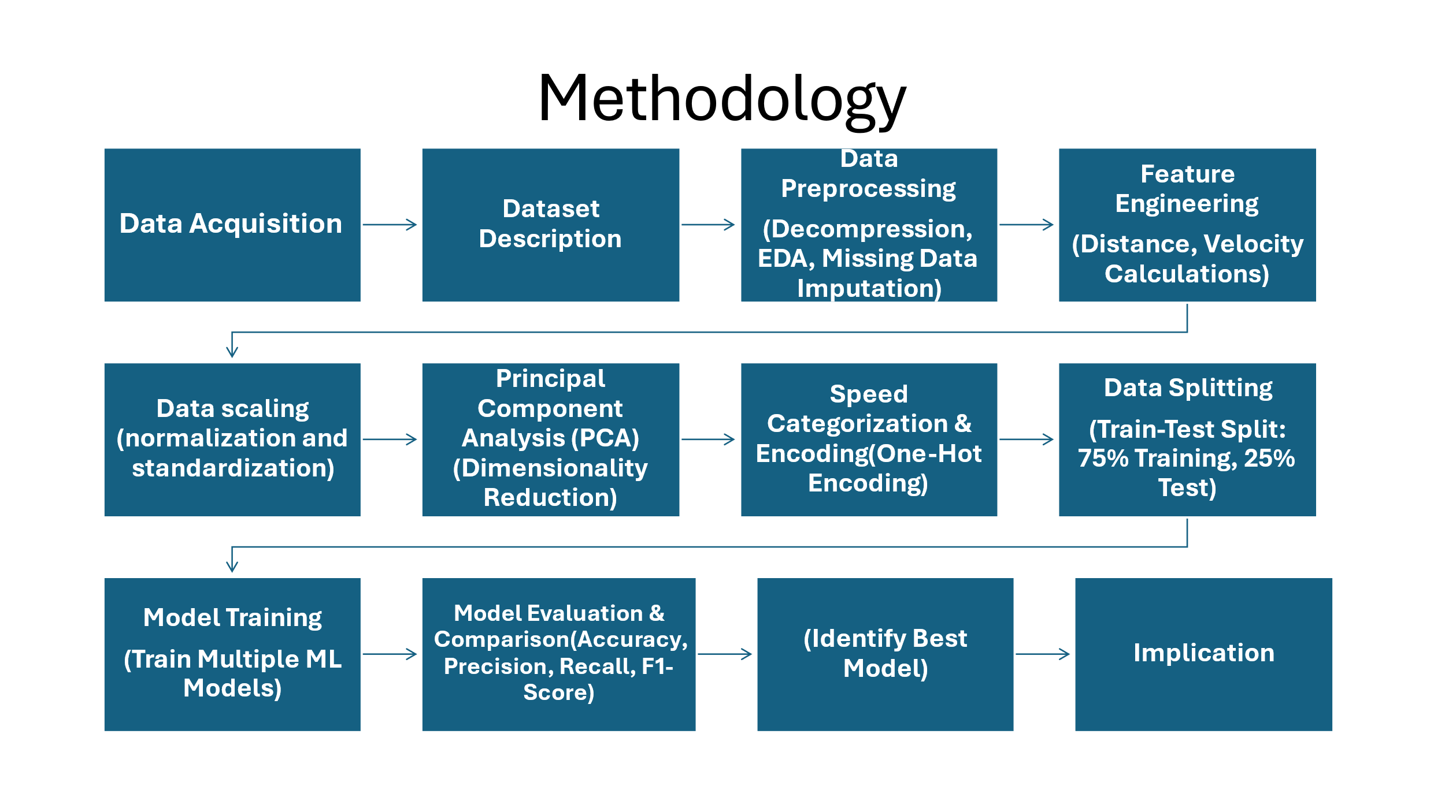
Fig, 1 : methodology

Data Acquisition: The GaitPhase database comprises data from 21 participants (10 male, 11 female) with an average age of 23.8 years, height of 172.8 cm, and weight of 66.6 kg. The dataset includes 25,306 steps recorded on a split-belt treadmill at 12 different speeds (0.6 to 1.7 m/s) for 1 minute each. Kinematic data were captured using a Qualisys motion capture system at 200 Hz, and kinetic data were collected from a Bertec split-belt treadmill at 1000 Hz. This synchronized data is valuable for studying human gait and supports various research applications, including the analysis of gait asymmetry and rehabilitation interventions (Hebenstreit et al., 2014).

Dataset Description: The dataset, stored in CSV format, includes time-series data of the x, y, and z coordinates of markers placed on the lower limbs, particularly the feet and ankles. This dataset provides a wide range of walking speeds, offering insights into various gait patterns and supporting the analysis of gait mechanics in both spatial and temporal domains. (Hebenstreit et al., 2014)

Data Preprocessing: Preprocessing is crucial due to noise, missing values, and other irregularities in raw data. Initial steps included decompressing the dataset, reading it into pandas Data Frames, and conducting exploratory data analysis (EDA). Descriptive statistics were calculated, and data visualizations helped identify unusual features (Baker, 2006; Witten et al., 2011; Altilio et al., 2021). Missing data were imputed using the mean for each column, preserving data integrity. (Chau, 2001; Zeni et al., 2008). [section VII -Fig 2, Fig 3, Fig 4 & Fig 5]
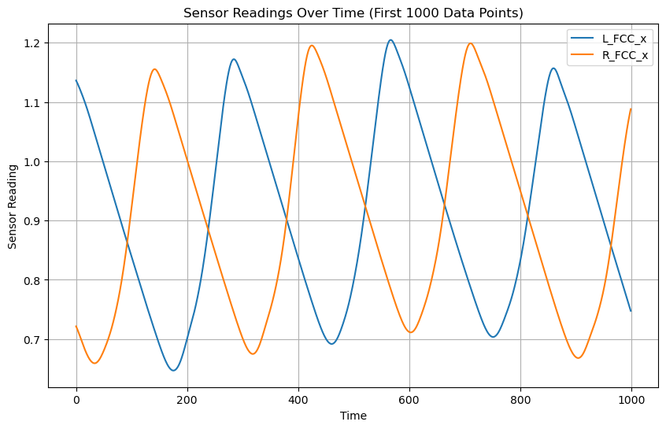Fig. 3 : Sensor Readings Over Time
Feature Engineering: Feature engineering involved creating meaningful features from raw positional data. To quantify essential features of gait mechanics, some features were derived from the raw marker data. Specific distances were obtained for specific pair of markers to allow for comparisons of the spatial relationship between various segments of the foot in the walking process. These distances are important for factors such as stride length and step width for which data need to be collected. Besides distances, velocities were estimated using derivatives of the position data with respect to time. Velocity features describe certain aspects of the dynamics of the gait, that is the magnitude of movement and direction, which is necessary for phase identification. Additionally, both standardization and normalization were applied to prepare the data for model training (Mannini & Sabatini, 2010; Witten et al., 2011; Altilio et al., 2021). [section VII- APPENDICES Fig 6, Fig 7, Fig 8, Fig 9 & Fig 10]

Principal Component Analysis (PCA): That was used to reduce dimensionality while retaining essential data variance, aiding in the prevention of overfitting (Jolliffe, 2002; Pundir et al., 2024). [Fig. 11]

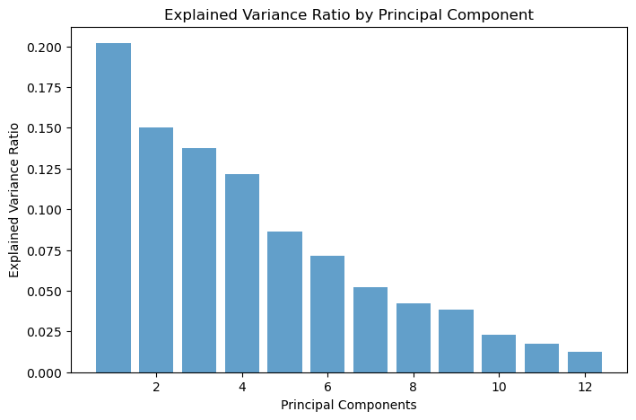
Fig. 11 : explained variance ratio by principal component
Speed Categorization and Encoding: The continuous speed variable was categorized into categorical data hence the different gait speeds were categorized from very slow speed, slow speed, medium speed, fast speed to very fast speed. This categorization was based on fixed speed intervals which after that were encoded using one-hot encoding. These categories were further transformed into a binary format through one-hot encoding to feed the machine learning models as well as to make predictions on gait speeds properly. (Witten, I. H. 2011, Bishop, C. M., 2006)

Data Splitting: The dataset was split into a 75% training set and a 25% test set, ensuring that a significant portion of the data was used for model training while reserving a separate set for testing the models' true efficiency (Kohavi, 1995).

Machine Learning Models:
Random Forest Classifier: Trained on PCA-transformed features using 100 trees. The model's performance was assessed through classification reports, confusion matrices, and feature importance plots to identify key predictors and misclassification patterns.( Breiman, L. ,2001)
Logistic Regression: Both L1 (Lasso) and L2 (Ridge) variations were trained and evaluated using classification reports, confusion matrices, and cross-validation to compare their handling of different data relationships. (Witten et al., 2011)
Neural Network: A two-layer neural network with dropout was trained using the Adam optimizer over 50 epochs. Performance was evaluated through classification accuracy, confusion matrices, and plots of training/validation loss and accuracy. (Kingma, D. P., & Ba, J. ,2014)
Gradient Boosting Classifier: Applied sequential tree building to improve predictions. Performance was assessed using classification reports, confusion matrices, and visualizations to demonstrate the model's ability to reduce bias.
(Friedman, Jerome H., 2001)
k-Nearest Neighbours (k-NN) Classifier: Trained with k=5, evaluated through cross-validation, classification reports, and confusion matrices, with visualizations highlighting prediction accuracy. (Witten, I. H. 2011, Witten, Kohavi, R. (1995))
Decision Tree Classifier: Trained to split data based on feature values. Performance was evaluated using classification reports, confusion matrices, and decision-making visualizations. (Breiman, L. (2001), Witten, I. H. 2011)
Naive Bayes Classifier: A Gaussian Naive Bayes model was trained with cross-validation, evaluated using classification reports and confusion matrices, demonstrating its effectiveness with a probabilistic approach. (Witten, I. H. 2011, Bishop, C. M., 2006)
Support Vector Machine (SVM) Classifier: Trained and evaluated in chunks due to the large dataset size. Performance was summarized with overall accuracy, classification reports, and confusion matrices, highlighting its ability to handle high-dimensional data. (Mangasarian, O. L., & Thompson, M. E. (2008).

Model Evaluation and Comparison:
The models were evaluated using accuracy, precision, recall, and F1-score. Confusion matrices were generated to understand the distribution of classifications, and feature importance analysis was conducted for models like Random Forest and Gradient Boosting (Breiman, 2001; Fawcett, 2006). Cross-validation was used to prevent overfitting, and model accuracy across gait speed categories (Fawcett, 2006).

Integration with Rehabilitation System: The best-performing model was integrated into a rehabilitation system that provides real-time feedback during exercises. This system tracks patient movement using a marker-based motion capture system, categorizes gait speed, and adjusts rehabilitation programs accordingly (Hribernik M, Umek A)

IV. Result

Best Performer Model: The Random Forest Classifier emerged as the top performer, achieving an impressive accuracy of 0.99. It consistently delivered high precision, recall, and F1-scores across all classes, with minimal misclassifications as indicated by its confusion matrix. The model’s robustness to noise and its ability to handle high-dimensional data were key factors contributing to its superior performance, making Random Forest a highly reliable choice for gait speed classification tasks.

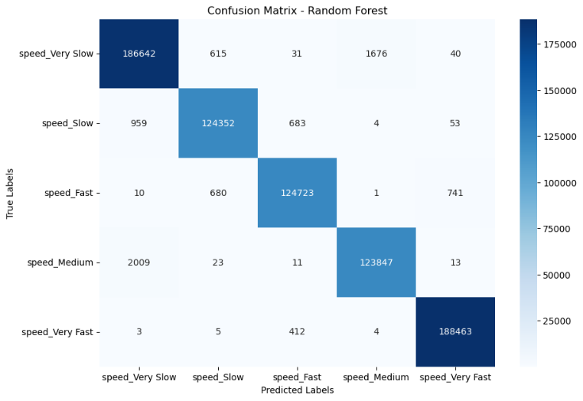 Fig, 12: Confusion Matrix for Speed Prediction Using Random Forest

The Random Forest model demonstrated strong performance in classifying speed categories, with particularly high accuracy for the "Very Slow" (186,642 correct) and "Very Fast" (188,463 correct) classes. Misclassifications are minimal, with some overlap in neighbouring classes like "Speed_Slow" and "Speed_Medium." For example, "Speed_Slow" was correctly classified 124,352 times but misclassified as "Very Slow" 959 times, and "Speed_Medium" was correctly classified 123,847 times with only minor errors, such as 2,009 instances misclassified as "Very Slow." Overall, the model effectively differentiates between the speed categories with few errors.

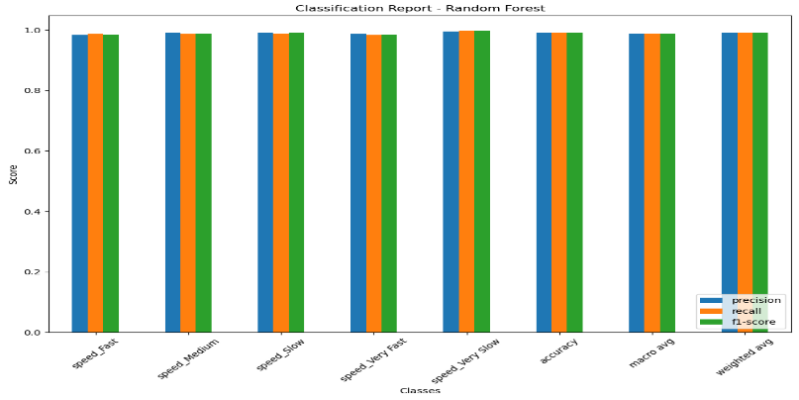 Fig,13 : Classification Report Metrics for Speed Prediction

The classification report for the Random Forest model showed excellent performance across all speed classes, with precision, recall, and F1-scores all very close to 1.0 for each class, including "Speed_Fast", "Speed_Medium", "Speed_Slow", "Speed_Very Fast" and "Speed_Very Slow." This indicated that the model consistently makes accurate predictions, correctly identifying the correct speed categories with high reliability. The overall accuracy, macro average, and weighted average scores are also close to 1.0, further confirming the model's robustness and effectiveness in classifying the speed categories. [section VII, Fig 12 & 13 as appendices]

Misclassified Samples Distribution in Principal Component Space (PC1 vs PC2) : The fig. 14 showed the distribution of misclassified samples in the space of the first two principal components (PC1 and PC2), with a total of 7,973 misclassified samples out of 756,000, resulting in a misclassification rate of approximately 1.05%. The data frame snippet indicates that for some samples, values for the principal components are missing (NaN), which may have impacted the model's classification performance. The presence of these NaN values suggests that some data might not have been fully processed or that certain principal components couldn't be computed for all samples, potentially contributing to the observed misclassifications. This visualization highlights the clustering of misclassified points and might offer insights into patterns or specific areas where the model's performance could be improved.

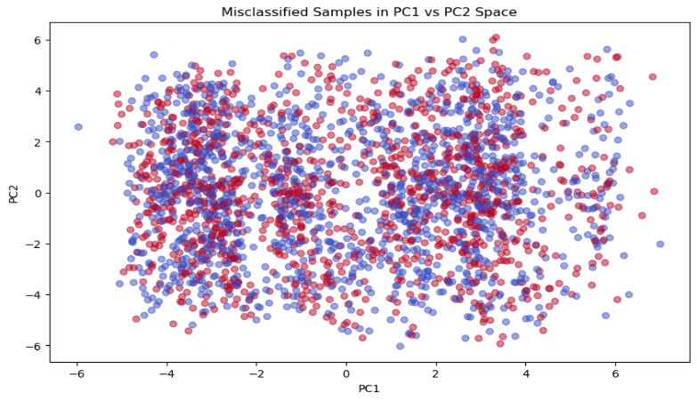
Fig : 14 – misclassified samples distributed between PC1 & PC2

Feature Importances of Principal Components: The Fig 15 was displayed the feature importances of the principal components (PCs) used in the model, highlighting which components contributed most to the model's predictions. PC3 stands out as the most important feature, with a significantly higher importance score compared to the other components. PC2 also showed notable importance, while the remaining components (PC8, PC5, etc.) contributed less significantly. This suggested that PC3 and PC2 captured the most critical information needed for the model's decision-making process.(section VII, Fig 15 as appendices)

Runner-Up: The k-Nearest Neighbours (k-NN) classifier demonstrated high accuracy in classifying different speed categories, achieving an overall accuracy of 0.98. Precision, recall, and f1-score metrics remained consistently high across all classes, with values ranging from 0.97 to 0.99. The confusion matrix indicated minimal misclassifications, with most true labels being accurately predicted. Notably, the "speed Very Slow" class achieved a near-perfect recall of 1.00, showcasing the model's strong performance. The macro and weighted averages for precision, recall, and f1-score were all 0.98, indicating that the classifier maintained its effectiveness across different classes. Cross-validation scores, ranging from 0.971 to 0.972, further reinforced the robustness of the model, with a mean cross-validation score of 0.972, highlighting the k-NN model's ability to accurately distinguish between varying speed levels in the dataset. (Fig, 16 & Fig 17)

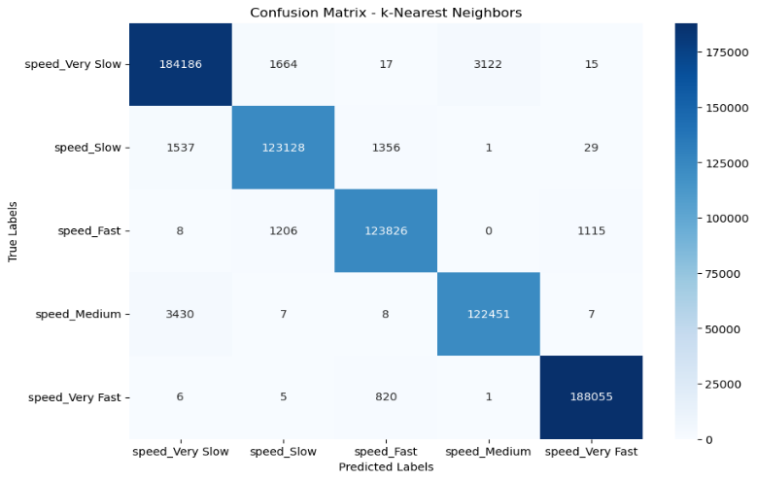
FIG : 16 – confusion matrix for KNN

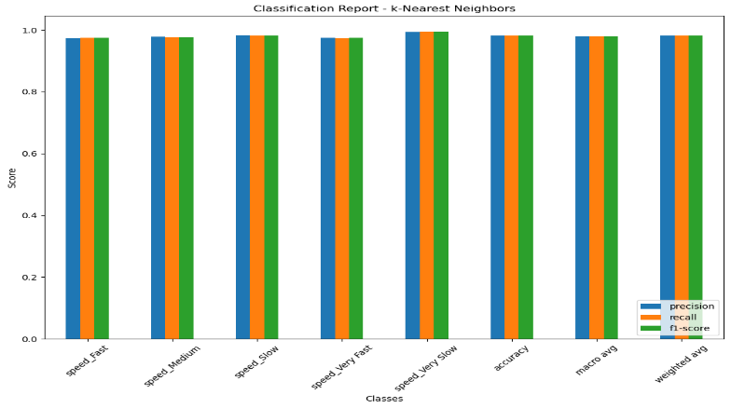
FIG. 17 : classification report for KNN

SVM Performance: it was employed a Support Vector Machine (SVM) classifier to predict speed categories within a large dataset, divided into five classes: "speed Fast," "speed Medium," "speed Slow," "speed Very Fast," and "speed Very Slow." The data was processed in chunks to manage memory efficiently, and the SVM was trained using a RBF kernel, which is well-suited for high-dimensional data. The chunking method enabled incremental learning and ensured efficient model training, preventing system overload and maintaining the integrity of the learning process. The model's performance was evaluated through cross-validation, yielding an overall accuracy of 98.12%. The classification results, reflected in the precision, recall, f1-scores, and confusion matrix, indicated that the SVM effectively distinguished between the speed categories, with minimal misclassifications. This approach demonstrated the robustness and effectiveness of SVM in handling large-scale, multi-class classification tasks, while also justifying the use of the chunking method to manage extensive datasets and facilitate accurate model performance. (section VII, Fig 18 & 19 as appendices). 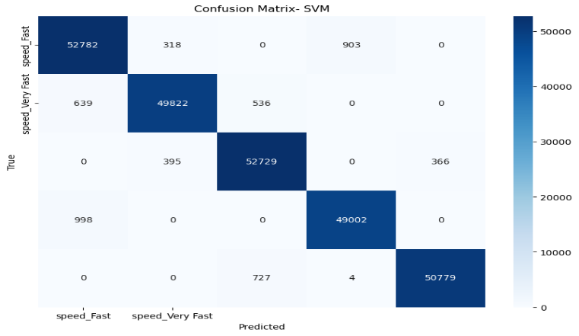
FIG :18 – confusion matrix for SVM

The chunking method was employed to effectively manage and process a large-scale dataset consisting of over 3 million samples across five speed classes, which would have been impractical to handle in a single pass due to memory and computational limitations. By dividing the dataset into smaller chunks of approximately 10,000 samples each, the method enabled incremental learning and ensured efficient model training. This approach was crucial in preventing system overload and maintaining the integrity of the learning process. The chunking method also allowed for selective processing of chunks containing multiple class labels, ensuring a balanced and representative sample for the SVM classifier. This strategy proved to be a robust solution for managing extensive datasets, facilitating efficient training and accurate model performance while avoiding resource consumption issues, thereby justifying its use in this research.

Neural Network Performance: The Neural Network classifier also showed strong performance, with an accuracy of 0.97. It achieved consistently high precision, recall, and F1-scores, making it slightly less accurate than Random Forest and SVM but still highly effective. The Neural Network's ability to model complex, non-linear relationships in the data contributed to its strong results, making it a viable option for advanced gait analysis tasks. (section-VII Appendices, Fig 20, 21, 22 & 23)

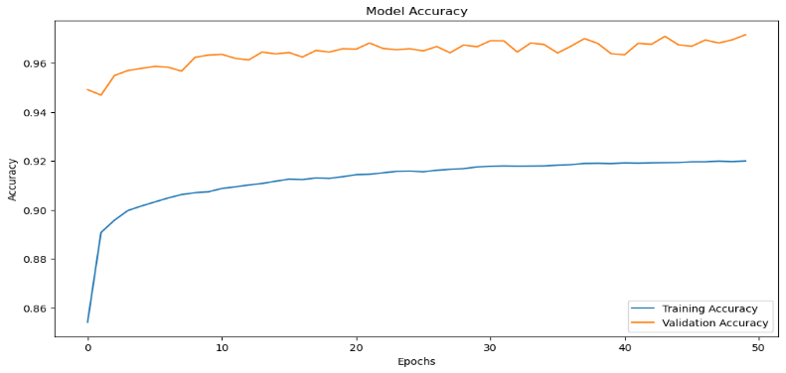 Fig 20 : Model Accuracy Over Epochs for Training and Validation Datasets

The figure 20 illustrated the model's performance over 50 epochs, showcasing both accuracy and loss for the training and validation datasets. In the accuracy graph, the training accuracy began lower and steadily increased, eventually stabilizing around 92%, while the validation accuracy remained consistently high, fluctuating slightly between 94% and 97%. This indicated that the model effectively learned from the data and generalized well to unseen samples without overfitting.
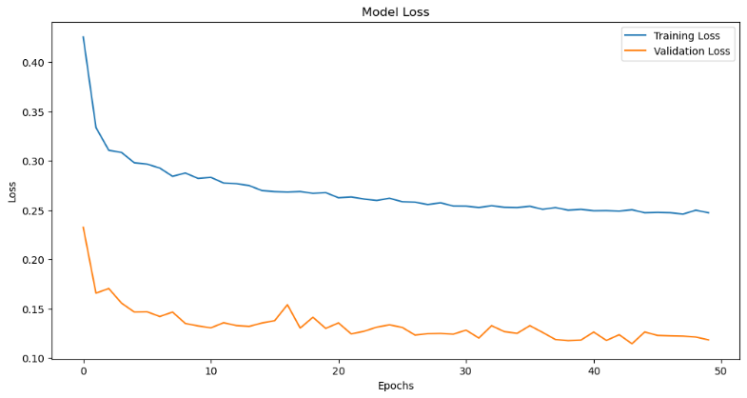 Fig 21:-Model Loss Over Epochs for Training and Validation Datasets"

In figure No. 21, the training loss started high and gradually decreased to around 0.25, reflecting a reduction in errors as the model trained. The validation loss, which started lower, also showed a decreasing trend, stabilizing around 0.13 with minor fluctuations. The consistent gap between training and validation loss suggested that the model was well-calibrated, maintaining its ability to generalize across different datasets. Together, these graphs demonstrated that the model was effectively learning and generalizing, with minimal overfitting, as indicated by the stable and close performance metrics across both datasets.

Moderate Performance: The Decision Tree classifier demonstrated strong performance across different speed categories, achieving an overall accuracy of 0.93. Precision, recall, and f1-score metrics were consistently high, ranging from 0.92 to 0.97 across the classes. The "speed Very Slow" class particularly stood out, with both recall and precision at 0.97, reflecting the model's strong ability to accurately identify this category. The confusion matrix indicated some misclassifications, particularly within the "speed Slow" and "speed Medium" classes, though these errors were relatively minor. The macro and weighted averages for precision, recall, and f1-score were all 0.93, indicating that the classifier maintained a balanced and effective performance across the various speed levels. The cross-validation scores, with a mean of 0.927, further confirmed the robustness and reliability of the Decision Tree model, making it well-suited for this classification task. (section-VII Appendices, Fig 24 & 25)
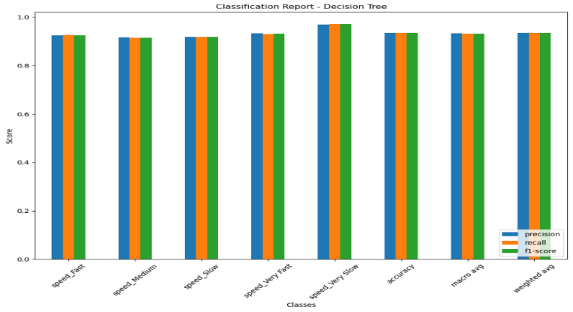
FIG 25 -CLASSIFICATION REPORT FOR DECISION TREE

Underperforming Models:
Gradient Boosting Classifier: This model exhibited a lower accuracy of 0.71, struggling particularly with slower gait speeds. This was evident in its lower precision and recall scores in those categories. (section-VII ,Fig 26 & 27)
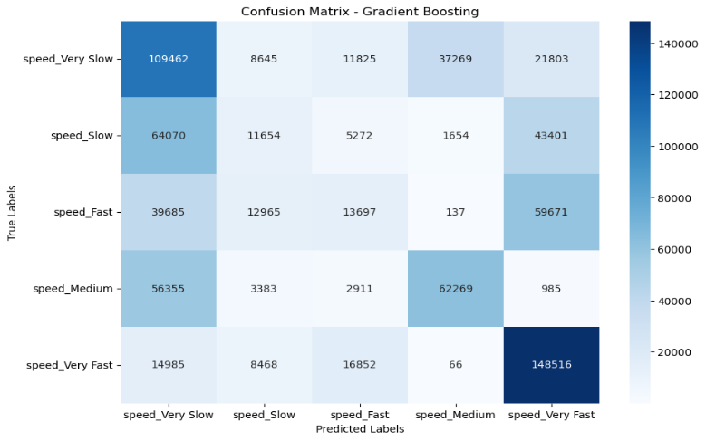 Fig 27 :-Confusion Matrix for Gradient Boosting

The confusion matrix for the Gradient Boosting model illustrated its performance in classifying different speed categories. Each row represented the actual class, while each column denoted the predicted class. The diagonal elements showed the number of correct predictions, whereas the off-diagonal elements indicated misclassifications. For example, the model correctly classified 109,462 samples as "speed_Very Slow" but incorrectly classified 21,803 of them as "speed_Very Fast." This matrix highlighted where the model performed well and where it struggled, particularly with confusion between "speed_Very Slow" and other classes like "speed Very Fast" and "speed Slow”.

The Gradient Boosting model was evaluated, and the confusion matrix revealed significant misclassifications, particularly among the "speed Slow" and "speed Fast" categories. The classification report showed that while the model performed relatively well in classifying "speed_Very Slow" and "speed_Very Fast," it struggled with intermediate speed categories, leading to lower precision, recall, and F1-scores for these classes. Overall, the model's accuracy was moderate, with better performance on the extreme ends of the speed spectrum but noticeable challenges in distinguishing between the middle categories.

Naive Bayes Classifier: The Naive Bayes classifier exhibited relatively lower performance compared to other models, achieving an overall accuracy of 0.45. The precision, recall, and f1-score metrics varied significantly across different speed categories, highlighting the model's challenges in this classification task. The "speed Fast" and "speed Very Slow" classes achieved higher recall rates of 0.77 and 0.85, respectively, indicating that the model could identify these categories relatively well. However, other classes, such as "speed Medium" and "speed Very Fast," performed poorly, with recall values as low as 0.06 and 0.13. This discrepancy suggests that while the model could handle certain categories, it struggled to generalize across all classes. The confusion matrix revealed substantial misclassifications, especially within the "speed Fast" and "speed Slow" categories. The macro average f1-score was 0.33, and the weighted average was 0.37, underscoring the model's overall imbalance in performance. Cross-validation scores were consistent, averaging 0.453, further confirming the model's limitations in effectively classifying the speed categories in the dataset. (section-VII Appendices, Fig 28 & 29)
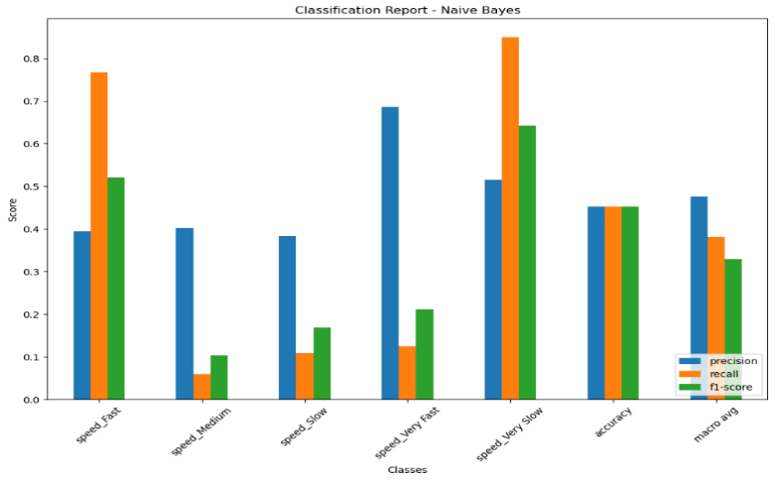Fig : 28 – Classification Report for Naïve Bayes

Logistic Regression: It was evaluated the performance of Logistic Regression models under different conditions, including standard Logistic Regression (with and without detailed misclassification analysis), and models with L1 and L2 regularization. The standard Logistic Regression model without regularization demonstrated the lowest accuracy at 40.49% and a high misclassification rate of 59.50%, with substantial challenges in predicting middle speed classes, as evidenced by the confusion matrix showing widespread misclassification across categories. The classification report further highlighted the model's struggles, particularly with low precision and recall for the "Speed Fast" and "Speed Slow" classes. Introducing L1 regularization slightly improved the accuracy to 46.77%, significantly enhancing recall for the "Speed Very Slow" class (F1-score of 0.65), although "Speed_Medium" and similar categories continued to show poor performance, as reflected in the confusion matrix. L2 regularization provided similar improvements, with an accuracy of 45.71% and a corresponding confusion matrix indicating persistent misclassification issues in middle-speed classes. Overall, while regularization marginally improved model performance, all versions of Logistic Regression faced considerable difficulties in accurately classifying intermediate speed categories, as consistently reflected in their confusion matrices and classification reports

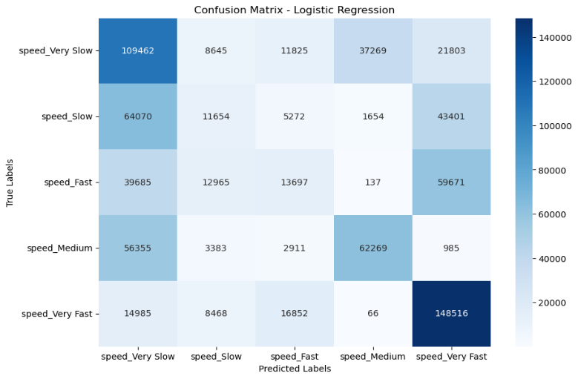
Fig 31: Confusion Matrix Analysis for Logistic Regression Model
L1 and L2 Regularization in Machine Learning: L1 and L2 regularization are techniques to prevent overfitting by adding penalties to the loss function. L1 regularization (Lasso) can shrink some coefficients to zero, effectively selecting features and simplifying the model. L2 regularization (Ridge) reduces the magnitude of all coefficients, making it effective for handling multicollinearity and retaining all features with less influence. Combining both methods, as in Elastic Net, balances feature selection with overall model stability. (section-VII Appendices, Fig 30 & 31)

Summary: - The table No. 02 summarized the performance of various classifiers, showing that the Random Forest model achieved the highest accuracy, precision, recall, and F1-score at 0.99, indicating it had the best performance with minimal misclassifications. KNN and SVM models also performed excellently, with scores of 0.98 across all metrics, highlighting their high accuracy and reliability. The Neural Network model followed closely with 0.97 in all metrics, showing strong performance. The Decision Tree consistently achieved 0.93 in all metrics. Gradient Boosting had lower performance, particularly struggling with slower speeds, reflected in its accuracy of 0.71. Logistic Regression and Naive Bayes models performed poorly, with accuracies of 0.46 and 0.45, respectively, and lower precision, recall, and F1-scores, indicating significant misclassifications. (section-VII Appendices, Table No. 02)

V. Discussion

Implications for Gait Analysis: This study reinforces the critical role that machine learning classifiers can play in advancing gait analysis, particularly in the classification of walking speeds using marker-based motion capture data. The strong performance of ensemble methods like Random Forest and non-parametric models such as k-Nearest Neighbours (k-NN) highlights their robustness in dealing with high-dimensional data and complex movement patterns. The ability of these models to accurately classify different gait speeds is especially valuable in clinical contexts, where early detection of gait abnormalities can significantly influence treatment outcomes for conditions such as Parkinson's disease, cerebral palsy, and post-surgical recovery.

Support Vector Machines (SVM), known for their effectiveness in high-dimensional spaces, also demonstrated robust performance, further validating their utility in gait analysis tasks. The chunking method employed in this study allowed for the efficient processing of large-scale datasets by dividing them into manageable portions. This approach was crucial in maintaining computational efficiency and preventing memory overload, which can be a significant challenge when working with SVMs on extensive datasets. Previous studies have also highlighted the effectiveness of chunking methods in large-scale SVM training, noting that it enables the model to incrementally learn from data without compromising the quality of the classification. The chunking method not only facilitated the use of SVM in this study but also ensured that the model could handle large, multi-class datasets with minimal loss in accuracy, thereby supporting its application in real-time gait analysis systems.

Neural Networks, while slightly less accurate than Random Forest and SVM, proved effective in capturing non-linear relationships within the data, which is crucial for understanding the subtle complexities of human gait. This capability makes Neural Networks particularly suitable for more nuanced gait analysis tasks, such as distinguishing between very similar gait patterns that might be indicative of different underlying health conditions.

Limitations and Future Work: Despite the promising results, the study's limitations, particularly regarding data imbalance, must be acknowledged. The dataset used in this study may not fully represent the diversity of gait patterns found in broader populations, which could limit the generalizability of the findings. Addressing data imbalance through techniques like synthetic data generation, oversampling, or advanced deep learning methods could enhance the models' ability to accurately classify less common gait patterns, thereby improving their utility in diverse clinical scenarios.

Additionally, while this study has focused on classifying gait speeds, the models could be further refined to classify other important gait characteristics, such as stride length, cadence, and symmetry, which are also critical indicators of gait health. Expanding the scope of classification could provide a more comprehensive assessment of gait and potentially lead to earlier detection of movement disorders.

Another area for future research is the integration of these machine learning models with wearable technology, such as inertial measurement units (IMUs) or pressure-sensitive insoles. These devices could capture real-time data, allowing for continuous monitoring and immediate feedback, which is particularly beneficial in rehabilitation settings where real-time adjustments can enhance patient outcomes.

Moreover, this study opens the door for exploring the interpretability of machine learning models in clinical settings. While models like Random Forest and SVM have demonstrated high accuracy, their black-box nature can pose challenges in clinical adoption. Future research could focus on developing explainable AI techniques that provide clinicians with understandable insights into how these models make decisions, thereby increasing trust and adoption in clinical environments.

Scalability and Real-Time Applications: The scalability of the machine learning models used in this study is an important consideration, especially when integrating these systems into real-time clinical applications. The ability to process large datasets efficiently without sacrificing accuracy is crucial for developing practical, real-time gait analysis systems. The chunking method used in the SVM model is a prime example of how computational challenges can be effectively managed, ensuring that the models remain responsive and accurate even when applied to extensive datasets. This scalability is essential for future applications in clinical settings, where real-time analysis can provide immediate feedback and improve patient outcomes.

VI. Conclusion:

In conclusion, this research has successfully demonstrated the potential of machine learning classifiers in gait analysis, with Random Forest, k-Nearest Neighbours, and SVM standing out as the most effective models for classifying walking speeds. Neural Networks also showed considerable promise, particularly in tasks requiring the modelling of complex, non-linear relationships. The justification of the chunking method for SVM training, supported by previous research, highlights its critical role in managing large datasets, ensuring efficient computation without sacrificing accuracy.

These findings contribute significantly to the field of gait analysis, offering robust models that can be integrated into real-world clinical systems to enhance the diagnosis and treatment of gait-related disorders. The study also lays the groundwork for future exploration of data imbalance, model interpretability, and real-time application, all of which are crucial for the continued advancement and adoption of machine learning in clinical gait analysis.

Broader Impact and Future Potential: The broader impact of this research extends beyond gait analysis, with potential applications in various areas of human movement analysis, such as sports science, biomechanics, and rehabilitation. The methodologies and models developed here could be adapted to analyze different types of movement patterns, offering insights into various health conditions and improving the effectiveness of rehabilitation programs. Future work could also explore the integration of these models with emerging technologies like augmented reality (AR) and virtual reality (VR), which could provide immersive and interactive rehabilitation environments, further enhancing patient engagement and outcomes.

Final Thoughts: As machine learning continues to evolve, its integration into clinical practice will likely become more prevalent. This study underscores the importance of continuing to refine these models, addressing current limitations, and ensuring that they are both accurate and interpretable for use in real-world healthcare settings. The promising results achieved in this research highlight the transformative potential of machine learning in enhancing gait analysis, providing a foundation for the development of next-generation systems that can improve patient care through more precise and efficient assessment of gait patterns.

Acknowledgements:

I would like to express my sincere gratitude to my supervisor, Mr. Tayyab Ahmad Ansari, for his continuous support, guidance, and encouragement throughout this project, I also thank my family and friends for their unwavering support and patience.

References:
- Muro-de-la-Herran, A., Garcia-Zapirain, B., & Mendez-Zorrilla, A. (2014). Gait Analysis Methods: An Overview of Wearable and Non-Wearable Systems, Highlighting Clinical Applications. Sensors, 14(2), 3362-3394. doi:10.3390/s140203362.
- Santos, G., Wanderley, M., Tavares, T., & Rocha, A. (2022). A multi-sensor human gait dataset captured through an optical system and inertial measurement units. Scientific Data, 9(1). https://doi.org/10.1038/s41597-022-01638-2.
- Chau, T. (2001). A Review of Analytical Techniques for Gait Data. Part 1: Fuzzy, Statistical and Fractal Methods. Gait Posture, 13(1), 49-66.
- Baker, R. (2006). Gait Analysis Methods in Rehabilitation. Journal of NeuroEngineering and Rehabilitation, 3, 4. doi:10.1186/1743-0003-3-4.
- Munoz-Ospina, B., Alvarez-Garcia, D., Clavijo-Moran, H. J. C., Valderrama-Chaparro, J. A., García-Peña, M., Herrán, C. A., Urcuqui, C. C., Navarro-Cadavid, A., & Orozco, J. (2022). Machine learning classifiers to evaluate data from gait analysis with depth cameras in patients with Parkinson’s disease. Frontiers in Human Neuroscience, 16. https://doi.org/10.3389/fnhum.2022.826376.
- Whittle, M. W. (2014). Gait Analysis: An Introduction. Butterworth-Heinemann.
- Breiman, L. (2001). Random Forests. Machine Learning, 45(1), 5-32.
- Zeni, J. A., Richards, J. G., & Higginson, J. S. (2008). Two Simple Methods for Determining Gait Events during Treadmill and Overground Walking Using Kinematic Data. Gait & Posture, 27(4), 710-714. doi:10.1016/j.gaitpost.2007.07.007.
- Mannini, A., & Sabatini, A. M. (2010). Machine Learning Methods for Classifying Human Physical Activity from On-Body Accelerometers. Sensors, 10(2), 1154-1175. doi:10.3390/s100201154.
- Altilio, R., Rossetti, A., Fang, Q., et al. (2021). A comparison of machine learning classifiers for smartphone-based gait analysis. Med Biol Eng Comput, 59, 535-546. doi:10.1007/s11517-020-02295-6.
- Rohan, A., Mohamed, R., Tarek, H., & Seunghae, K. (2020). Human Pose Estimation-Based Real-Time Gait Analysis Using Convolutional Neural Network. IEEE Access, 8
- Slemenšek, J., Fister, I., Geršak, J., Bratina, B., van Midden, V. M., Pirtošek, Z., & Šafarič, R. (2023). Human Gait Activity Recognition Machine Learning Methods. Sensors, 23(2), 745. https://doi.org/10.3390/s23020745.
- Yang, M., Zheng, H., Wang, H., & McClean, S. (2009). Feature selection and construction for the discrimination of neurodegenerative diseases based on gait analysis. Third IEEE Int Conf Pervasive Comput Technol Healthc.
- Witten, I. H., Frank, E., & Hall, M. A. (2011). Data Mining: Practical Machine Learning Tools and Techniques (3rd ed.). Morgan Kaufmann.
- Privietha, P., & Raj, V. J. (n.d.). Deep learning technic on gait analysis. Retrieved from https://iqac.kamarajcollege.ac.in/wp-content/uploads/3.3.2-Deep-Learning-Technic-on-Gait-Analysis.pdf
- Alfayeed, S. M., & Saini, B. S. (2021). Human Gait Analysis Using Machine Learning: A Review. 2021 International Conference on Computational Intelligence and Knowledge Economy (ICCIKE), Dubai, United Arab Emirates, pp. 550-554. doi:10.1109/ICCIKE51210.2021.9410678.
- Hebenstreit, F., Leibold, A., Krinner, S., Welsch, G., Lochmann, M., & Eskofier, B. M. (2014). Description of the GaitPhase Database.
- Jolliffe, I. T. (2002). Principal Component Analysis (2nd ed.). Springer.
- Pundir, A., et al. (2024). Enhancing gait recognition by multimodal fusion of mobilenetv1 and xception features via PCA for OaA-SVM classification. Scientific Reports, 14(1), 1-17.
- Bishop, C. M. (2006). Pattern Recognition and Machine Learning. Springer.
- Goodfellow, I., Bengio, Y., & Courville, A. (2016). Deep Learning. MIT Press.
- Fawcett, T. (2006). An introduction to ROC analysis. Pattern Recognition Letters, 27(8), 861-874.
- Hribernik M, Umek A, Tomažič S, Kos A. Review of Real-Time Biomechanical Feedback Systems in Sport and Rehabilitation. Sensors (Basel). 2022.
- Park, H., et al. (2023). Classification of gait phases based on a machine learning approach using muscle synergy. Frontiers in Human Neuroscience, 17. doi:10.3389/fnhum.2023.1201935.
- Kohavi, R. (1995). A study of cross-validation and bootstrap for accuracy estimation and model selection. International Joint Conference on Artificial Intelligence (IJCAI), 14, 1137-1145.
- S. Shetty and Y. S. Rao, "SVM based machine learning approach to identify Parkinson's disease using gait analysis," 2016 International Conference on Inventive Computation Technologies (ICICT), Coimbatore, India, 2016, pp. 1-5, doi: 10.1109
- B. Najafabadian, H. Jalali, A. Sheibani and K. Maghooli, "Neurodegenerative Disease Classification Using Nonlinear Gait Signal Analysis, Genetic Algorithm and Ensemble Classifier," Electrical Engineering (ICEE), Iranian Conference on, Mashhad, Iran, 2018.
- Mangasarian, O. L., & Thompson, M. E. (2008). Chunking for massive nonlinear kernel classification. Optimization Methods and Software, 23(3), 365–374. https://doi.org/10.1080/10556780701611976.
- Kingma, D. P., & Ba, J. (2014). Adam: A Method for Stochastic Optimization 1412.6980 (arxiv.org))
- Friedman, Jerome H. “Greedy Function Approximation: A Gradient Boosting Machine.” The Annals of Statistics, vol. 29, no. 5, 2001, pp. 1189–232. JSTOR, http://www.jstor.org/stable/2699986. Accessed 22 Aug. 2024.

VI. APPENDICES
Table 2 : Summary of Classifier Performance Results
Classifier | Accuracy | Precision | Recall | F1-Score | Notes
Decision Tree | 0.93 | 0.93 | 0.93 | 0.93 | Consistent performance across all classes
KNN | 0.98 | 0.98 | 0.98 | 0.98 | High accuracy and minimal misclassifications.
Gradient Boosting | 0.71 | 0.70 | 0.68 | 0.68 | Lower performance, struggles particularly with slower speeds.
Random Forest | 0.99 | 0.99 | 0.99 | 0.99 | Best performance with minimal misclassifications.
Neural Network | 0.97 | 0.97 | 0.97 | 0.97 | Strong performance, slightly below Random Forest.
Navies bias | 0.45 | 0.48 | 0.38 | 0.33 | Performance is below average, especially in recall and F1-score.
SVM | 0.98 | 0.98 | 0.98 | 0.98 | Excellent performance, comparable to KNN, with high accuracy.
Logistic Regression (L1 Regularization) | 0.47 | 0.47 | 0.47 | 0.40 | Slight improvement with L1 regularization, but still underperforming.
Logistic Regression (L2 Regularization) | 0.46 | 0.41 | 0.41 | 0.39 | Similar results to basic Logistic Regression, still underperforming
Logistic Regression | 0.46 | 0.41 | 0.41 | 0.39 | Poor performance, significant misclassifications

-
Fig, 1 : methodology
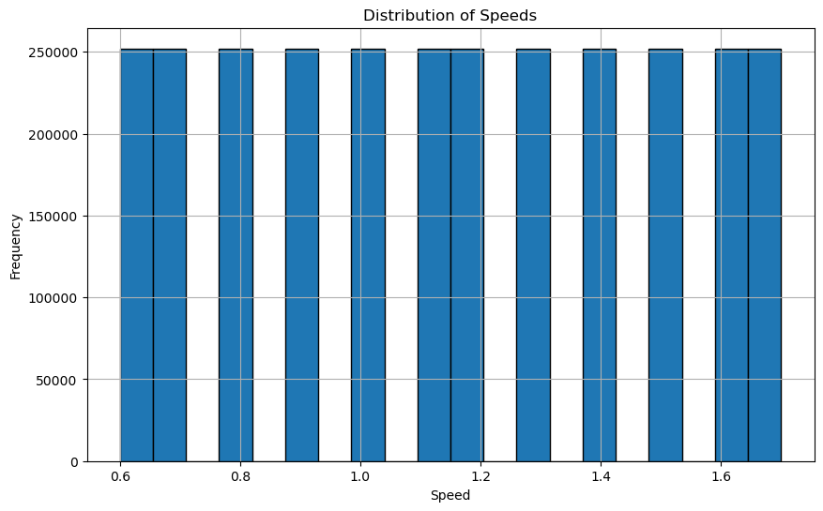
Fig. 2 : Distribution of Speeds:
This plot shows a histogram or bar chart depicting the frequency of different speeds in your dataset. The x-axis would represent speed values, and the y-axis would show the frequency (how often each speed occurs). A uniform distribution might indicate balanced data collection across different speeds.

Fig. 3 : Sensor Readings Over Time:
This plot visualize sensor readings over time for two different sensors, such as L_FCC_x and R_FCC_x. The x-axis would represent time (or sample points), and the y-axis would show sensor readings. This plot could be used to observe the periodic nature of the sensor data, which is common in gait analysis.

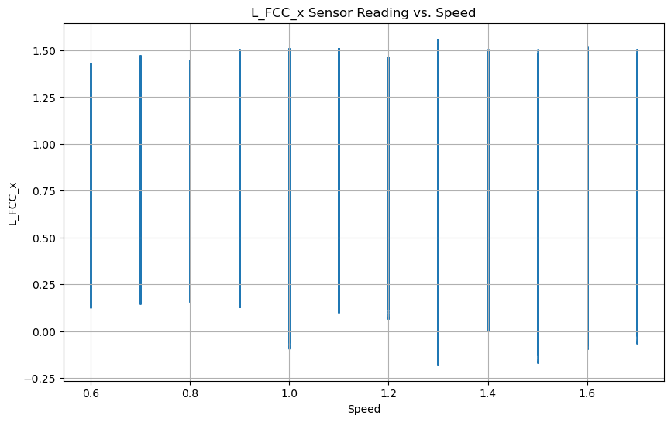
Fig. 4 : Sensor Reading vs. Speed:
This plot show the relationship between sensor readings and different speed values. The x-axis represents speed, and the y-axis represents the sensor reading. This could be a scatter plot or a line plot, useful for identifying any correlation between speed and sensor measurements.
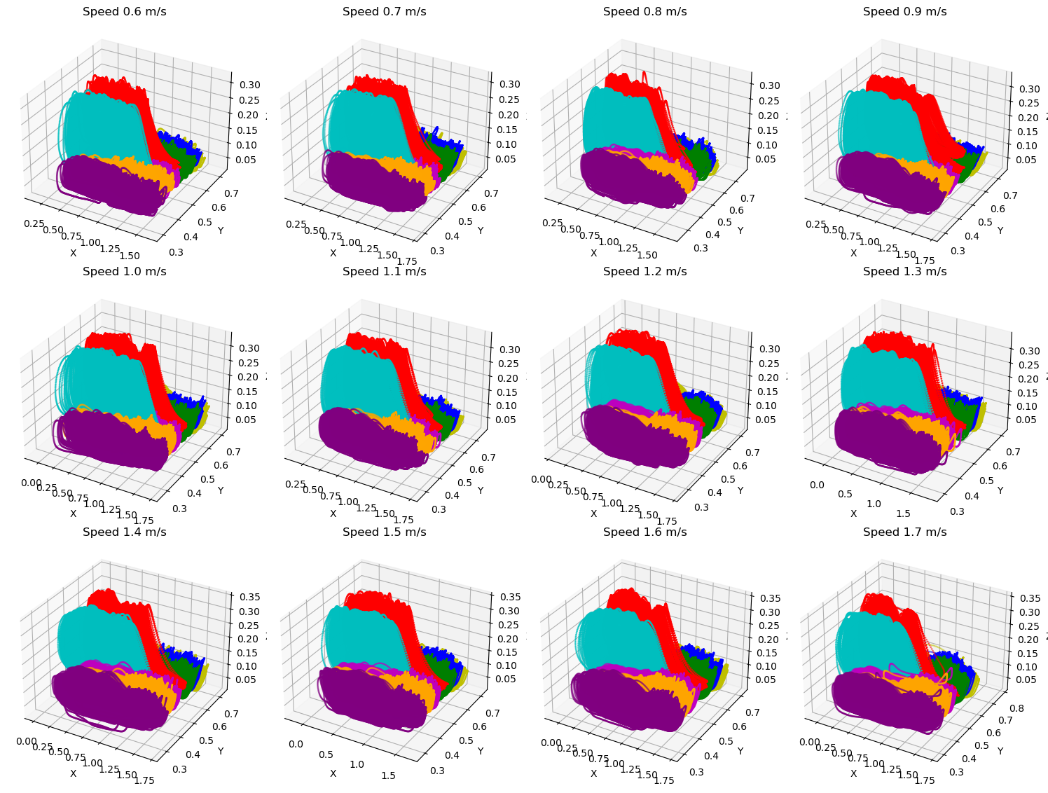
Fig.5: 3D Gait Analysis Across Different Walking Speeds:
3D plots comparing gait data at various speeds (0.6 to 1.7 m/s). Each plot likely represents spatial foot position or pressure distribution, with color coding differentiating data types. This visualization helps analyze how gait patterns change with speed.

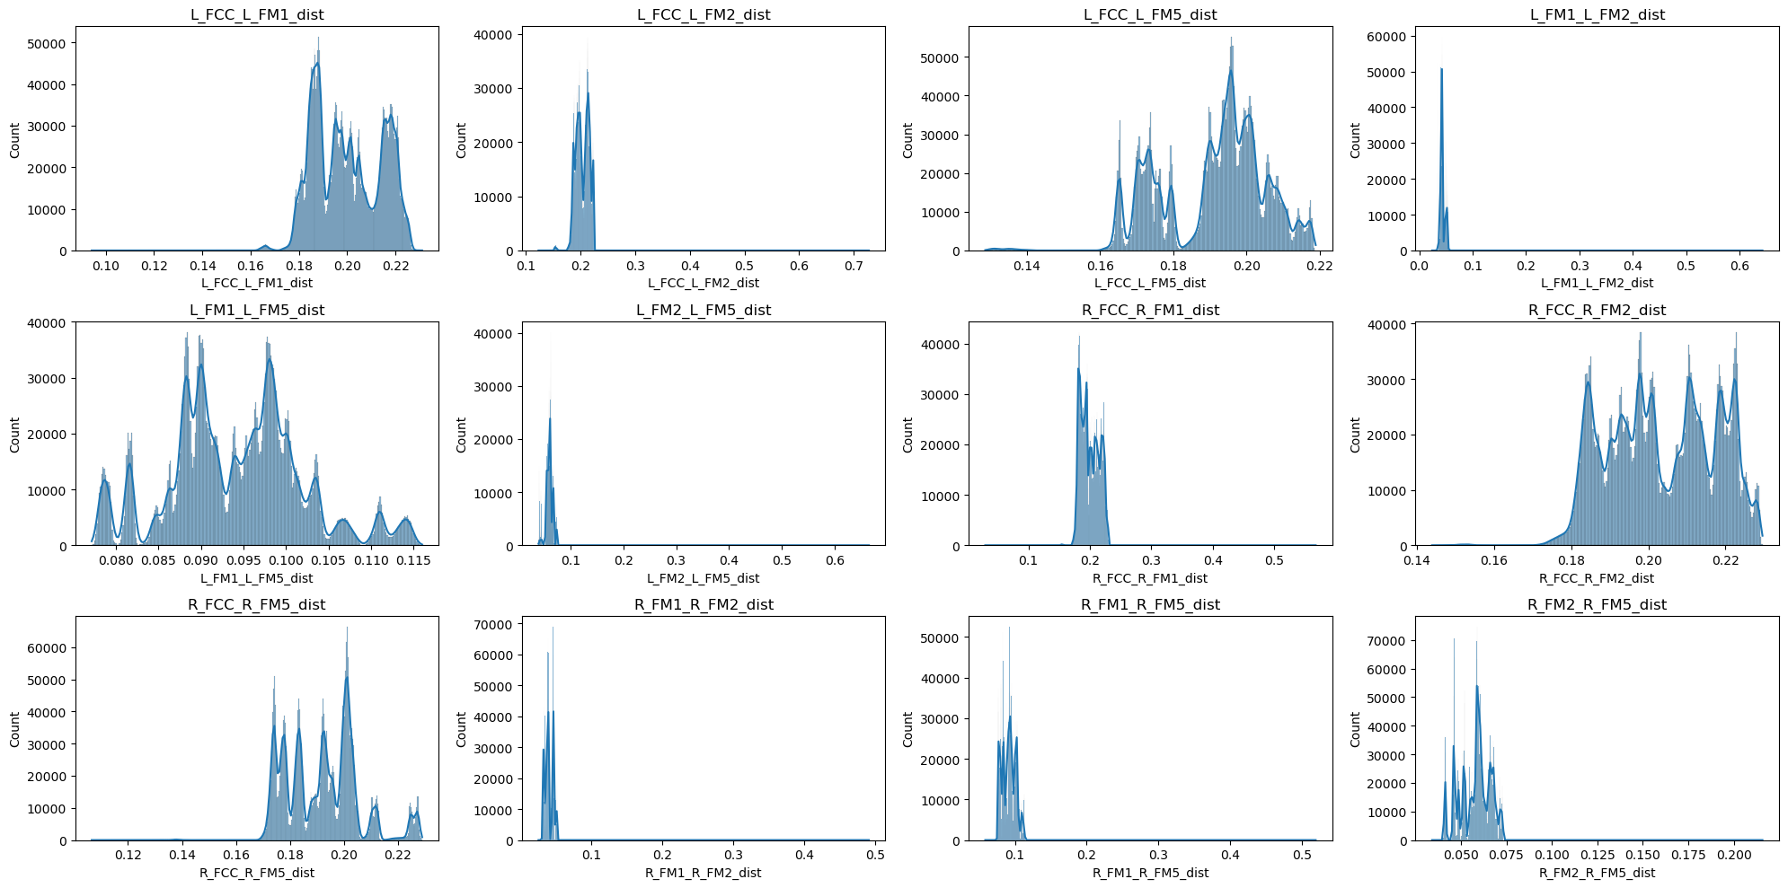
Fig. 6 : Distribution of Distances Between Gait Markers :The image shows multiple histograms, each representing the distribution of distances between different pairs of gait markers or features (e.g., L_FCC_L_FM1_dist, R_FCC_R_FM1_dist). The x-axis in each plot represents the distance, while the y-axis represents the count or frequency of those distances.

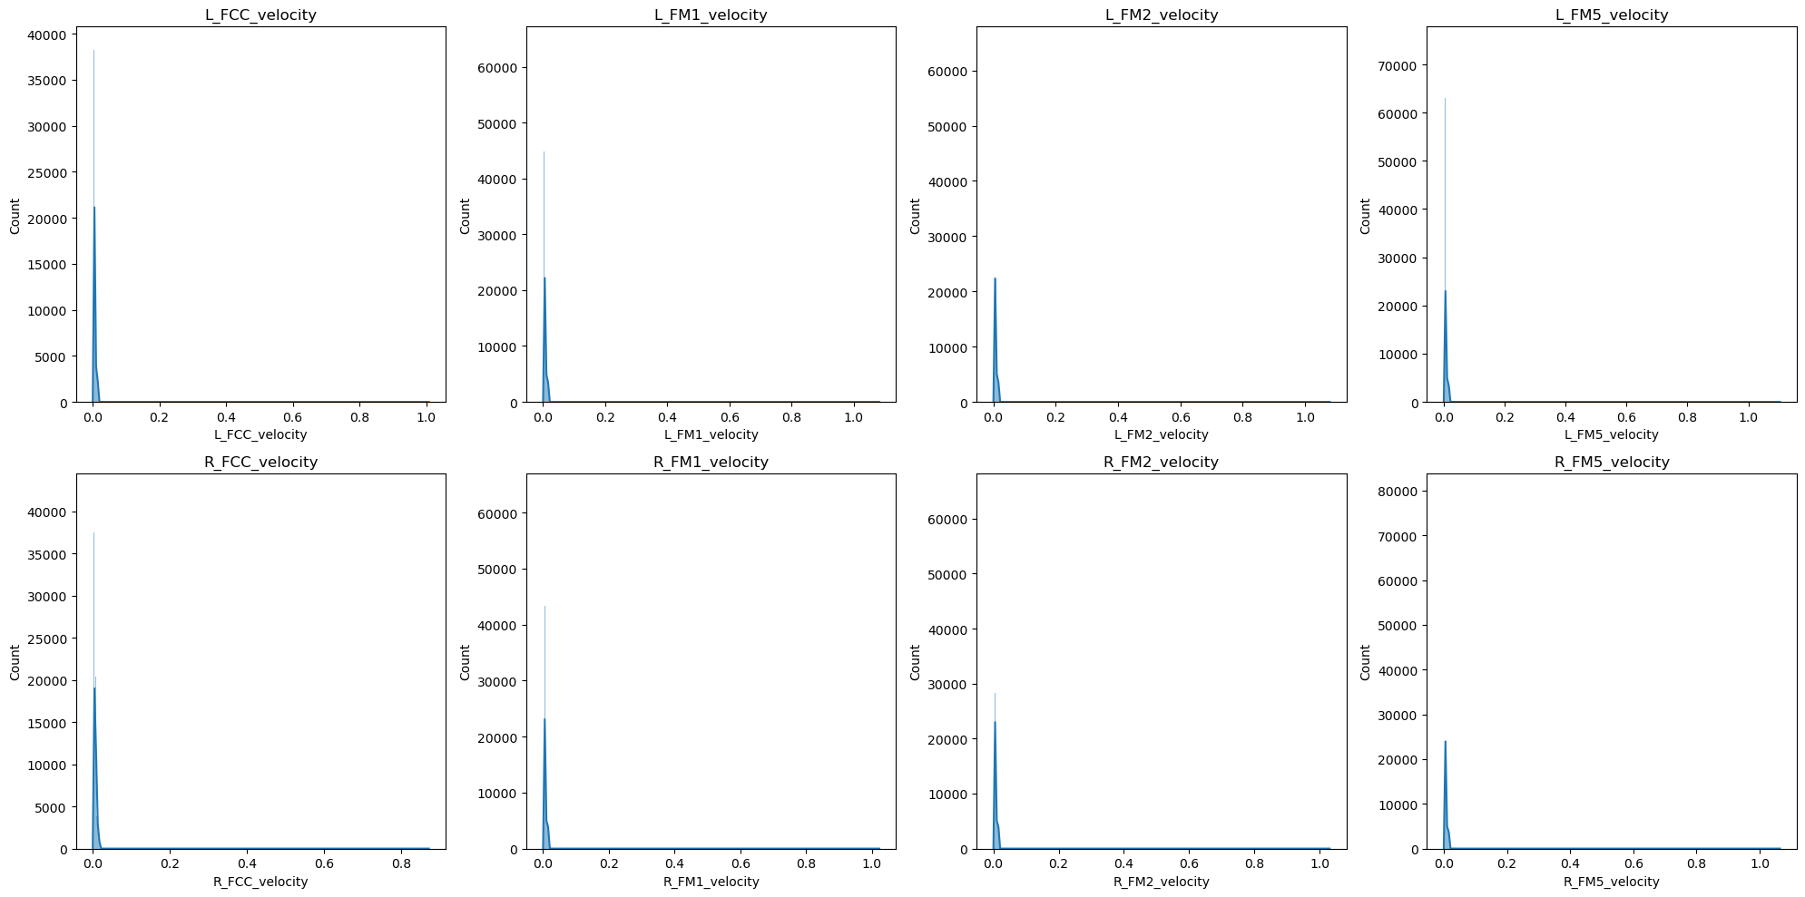
Fig 7 : Velocity Distribution of Gait Markers : The image shows a set of histograms displaying the distribution of velocities for different gait markers, such as L_FCC_velocity, R_FM1_velocity, etc. The x-axis represents the velocity, and the y-axis shows the count or frequency of these velocity values

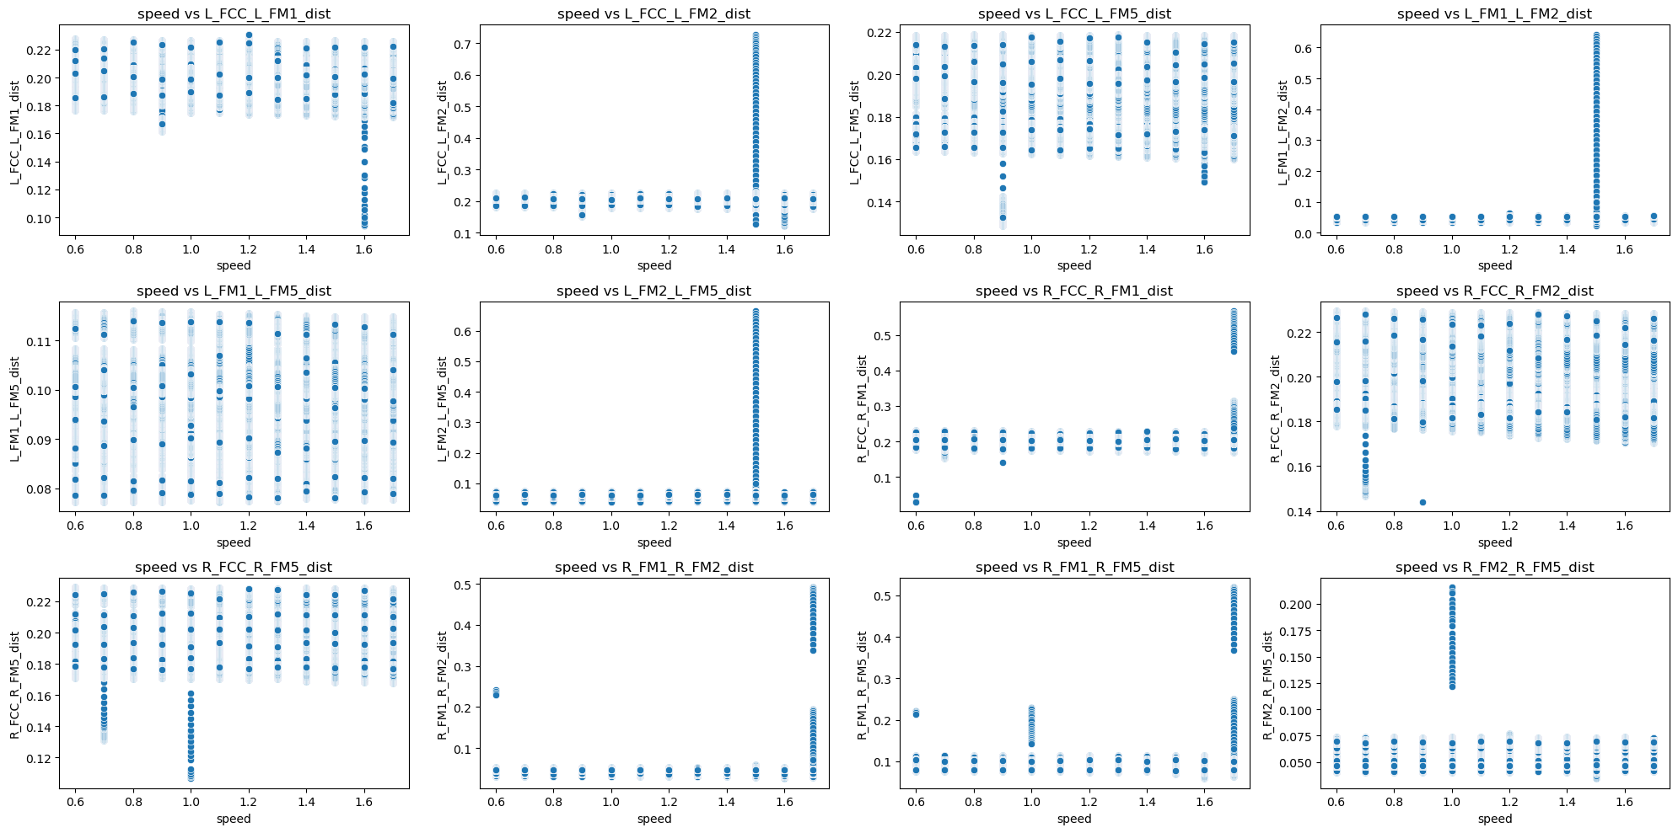
Fig. 8: Relationship Between Gait Marker Distances and Speed:
The image displays a series of scatter plots showing the relationship between speed and the distances between various gait markers (e.g., L_FCC_L_FM1_dist). The x-axis represents speed, and the y-axis represents the distance.

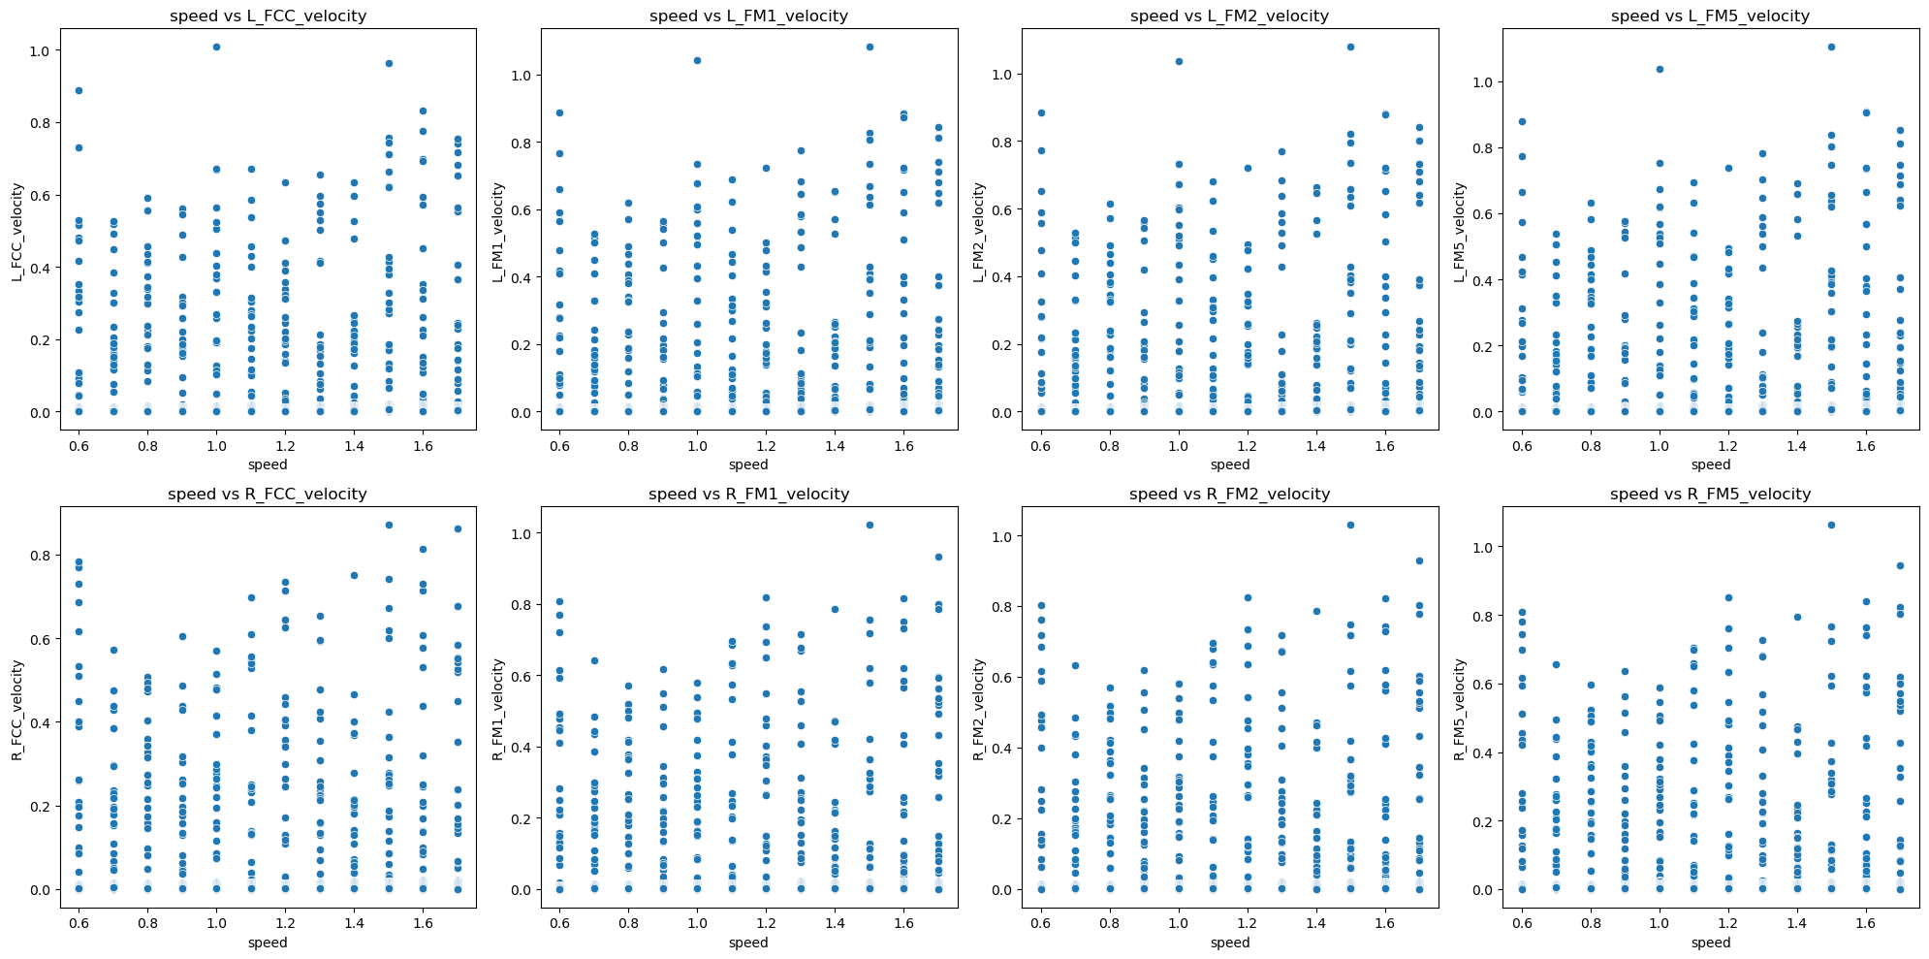
Fig. 9: Relationship Between Gait Marker Velocities and Speed: The image displays scatter plots illustrating the relationship between speed and the velocities of various gait markers (e.g., L_FCC_velocity, R_FM1_velocity). The x-axis represents speed, and the y-axis represents velocity.

p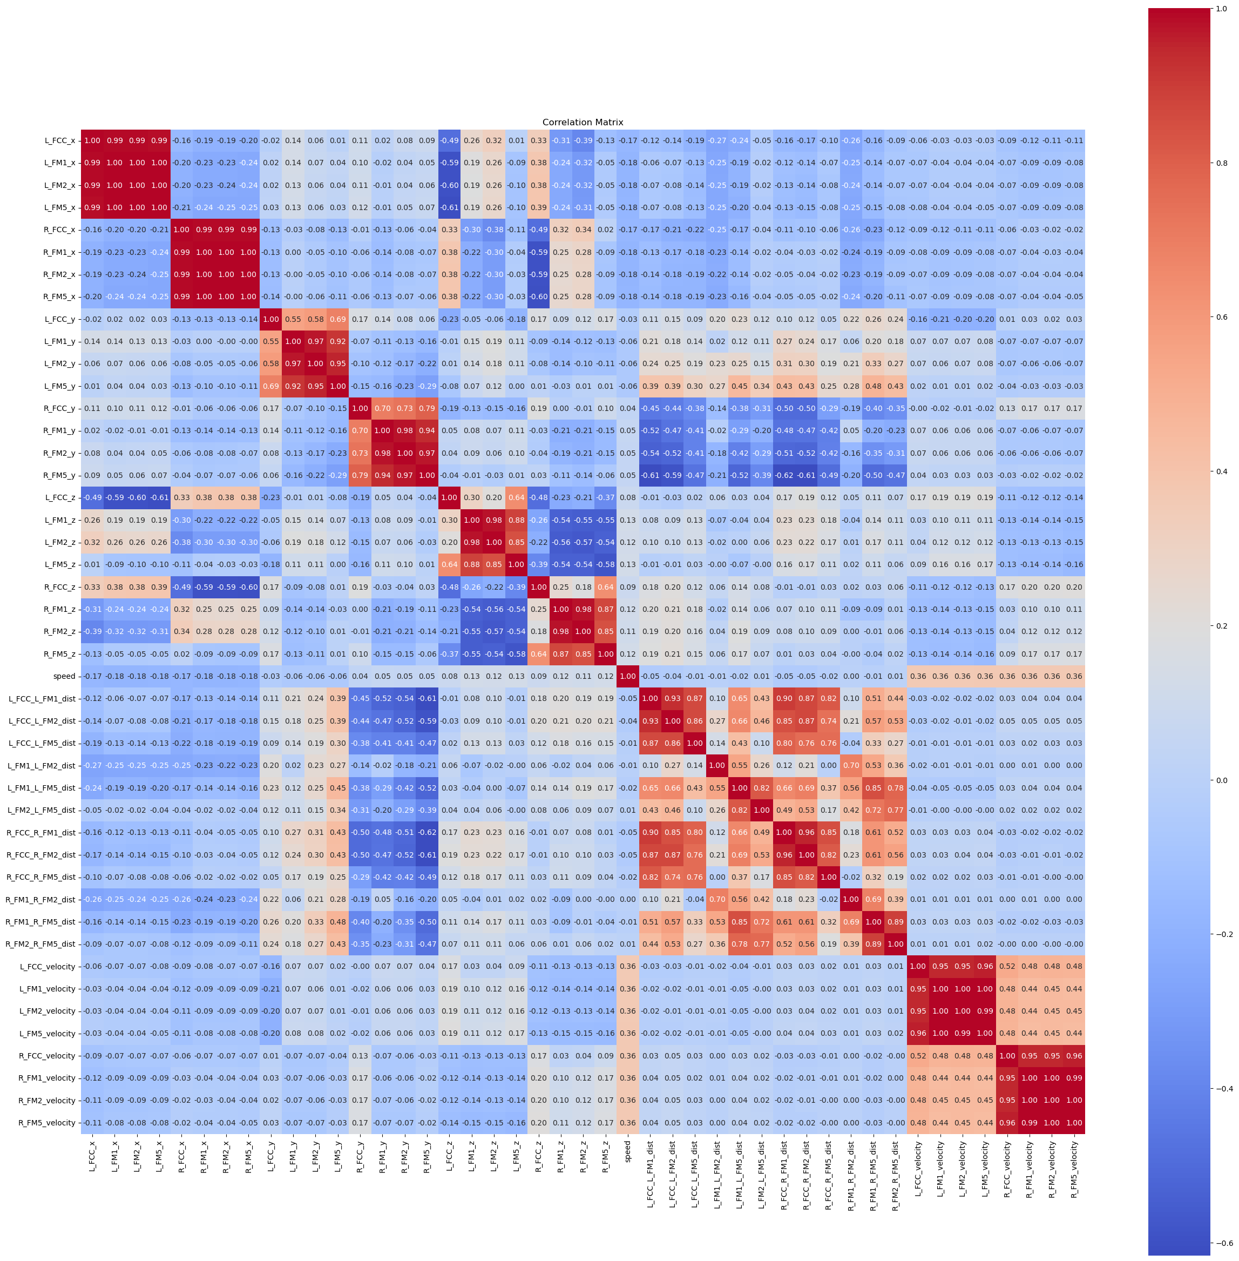

Fig. 10: Correlation Matrix of Gait Markers, Velocities, and Distances:
The image shows a correlation matrix, which visually represents the correlation coefficients between different gait markers and their corresponding velocities and distances. The matrix uses a color gradient, where red indicates a strong positive correlation,
blue indicates a strong negative correlation, and lighter colors indicate weaker correlations.


Fig. 11 : explained variance ratio by principal component


Fig, 12: Confusion Matrix for Speed Prediction Using Random Forest


Fig,13 : Classification Report Metrics for Speed Prediction Using Random Forest


Fig : 14 – misclassified samples distributed between PC1 & PC2

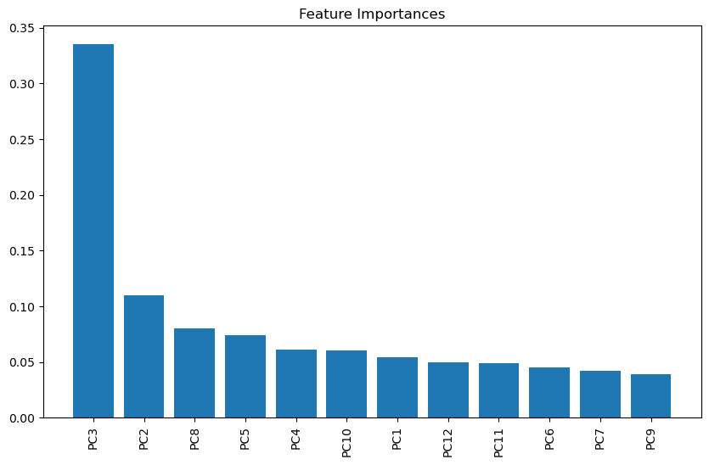
Fig 15 : Feature Importances of Principal Components


FIG : 16 – confusion matrix for KNN


FIG:17 – CLASSIFICATION REPORT FOR KNN


FIG :18 – confusion matrix for svm

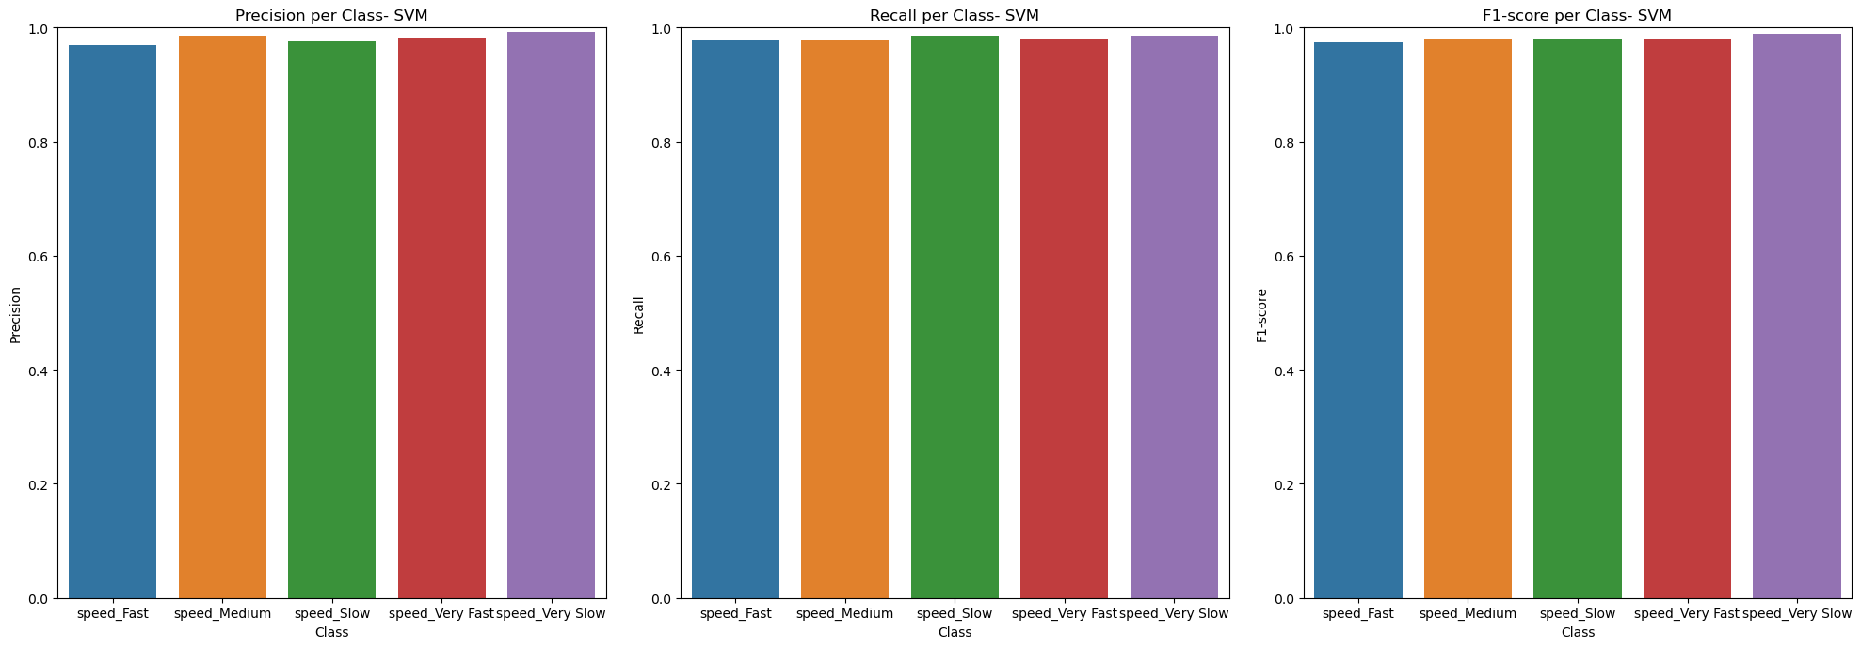
FIG 19 – CLASSIFICATION REPORT FOR SVM

 Fig 20 : Model Accuracy Over Epochs for Training and Validation Datasets

 Fig 21:-Model Loss Over Epochs for Training and Validation Datasets"

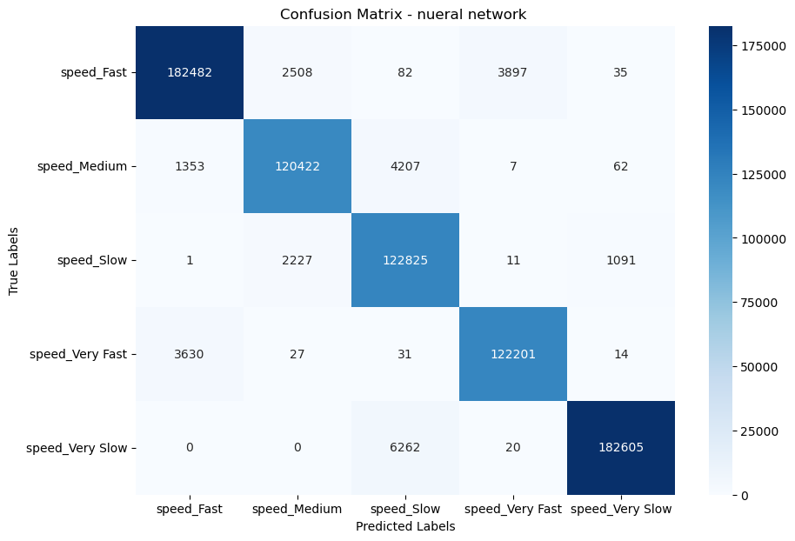
FIG: 22 - CONSFUSION MARTIX FOR NUERAL NETWORK

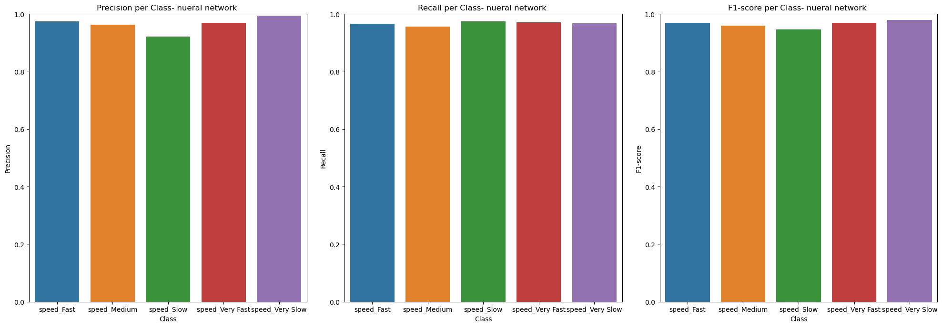
FIG : 23 – CLASSIFICATION REPORT FOR NUERAL NETWORK

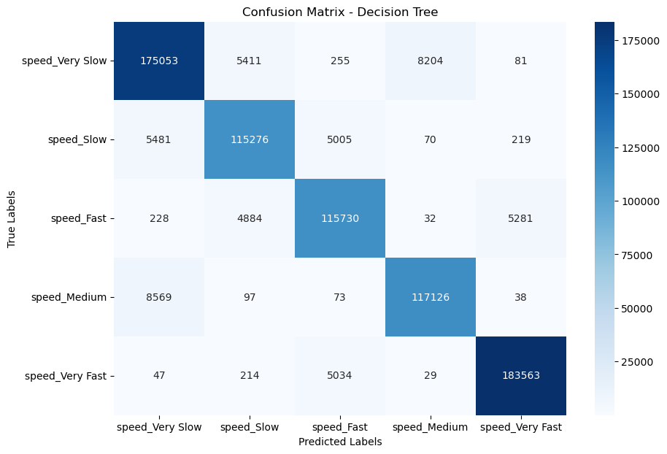
FIG : 24- CONFUSTION MATRIX FOR DECISION TREE


FIG 25 -CLASSIFICATION REPORT FOR DECISION TREE

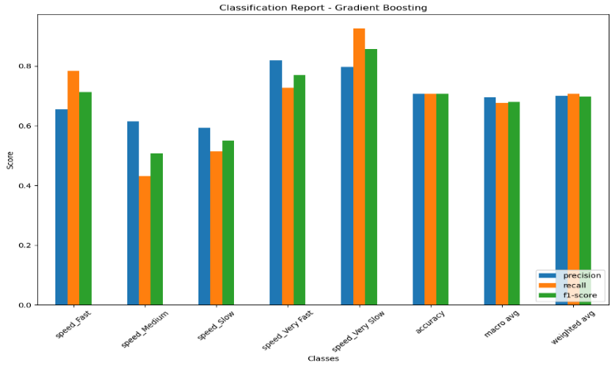
Fig 26 :- Classification Report for Gradient Boosting Model

 Fig 27 :-Confusion Matrix for Gradient Boosting

Fig : 28 – Classification Report for Naïve Bayes

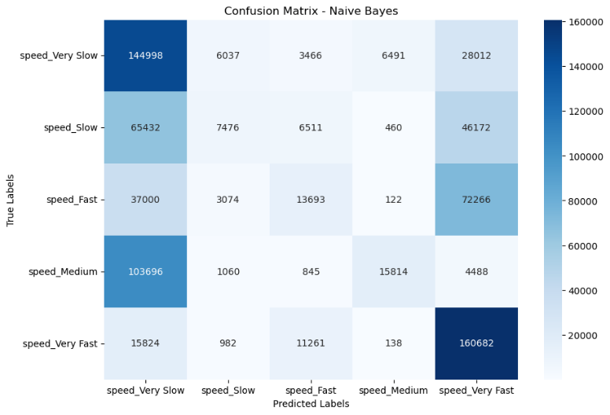
FIG : 29 – CONFUSTION MARTIX FOR NAÏVE BAYES

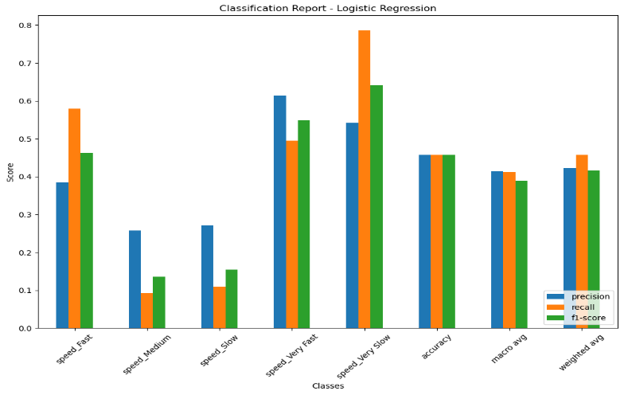
Fig 30 :- Performance Summary of Logistic Regression Model Across Speed Classes


Fig 31 : Confusion Matrix Analysis for Logistic Regression Model

